**Architecture for T-COM and T-Cloud Computing Platform**

|  |
| --- |
| Authors: |
| L. Pearlstein |
|  |
|  |
|  |
|  |
|  |
|  |

NOTE: Document revisions should be managed via the IMPL GitLab repository, “tcom_engineering”.

Table of Contents

2 Acronyms and Glossary 3

3 Introduction 3

# Acronyms and Glossary

CO – chemical symbol for carbon monoxide

mHealth – mobile health. Includes things like FitBits and wearable cardiac monitors.

NIH – National Institutes of Health

T-Cloud – cloud computing platform associated with T-COM. Includes database, cloud applications for automated messaging, and on-demand messaging, and web-application to build a web-based dashboard for clinicians.

T-COM – TCNJ CO Monitor

# Introduction

The present document describes a system whose requirements emerged from the development of an innovative intervention for dependence on smoked tobacco. The intervention was proposed for funding by NIH, and the proposal can be found [here](Proposal%20to%20NIH%20for%20An%20Innovative%20mHealth%20Intervention.pdf).

The system includes the following components:

* T-COM device
* Cloud database
* Cloud applications
* Web server-side application
* Web server

and a block diagram is shown in Figure 1.

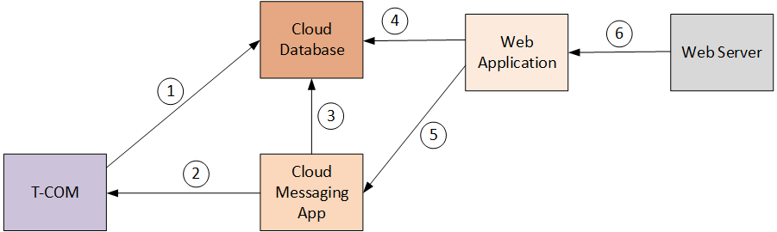

Figure 1: T-COM & T-Cloud Architecture Block Diagram

# System Interfaces

## T-COM to Cloud Database

|  |  |
| --- | --- |
| Layer | Interface |
| PHY | 3G modem to wireless base station |
| Network | TCP/IP |
| Application | MySQL database access API for ‘C’, binds to modem socket library calls. |

## Cloud Messaging Application to T-COM

|  |  |
| --- | --- |
| Layer | Interface |
| PHY | Internet to wireless base station to 3G modem |
| Network | TCP/IP or SMS (TBD) |
| Application | T-COM message notification and browsing software. |

## Cloud Messaging Application to Cloud Database

## Web Application to Cloud Database

## Web Application to Cloud Messaging Application

## Web Server to Web Application

# Top-Level Processing Blocks

# T-COM Hardware Architecture

A block diagram of the T-COM hardware is shown in Figure 2.



Figure 2: T-COM Hardware Block Diagram

A bill-of-materials for the T-COM main board is given in .

|  |  |  |  |  |  |
| --- | --- | --- | --- | --- | --- |
| Item number | Description | Mfr. Part Number | Quantity | Unit Cost | Extended Cost |
|  |  |  |  |  |  |
|  |  |  |  |  |  |
|  |  |  |  |  |  |
|  |  |  |  |  |  |
|  |  |  |  |  |  |
|  |  |  |  |  |  |
|  |  |  |  |  |  |

# T-COM Software Architecture